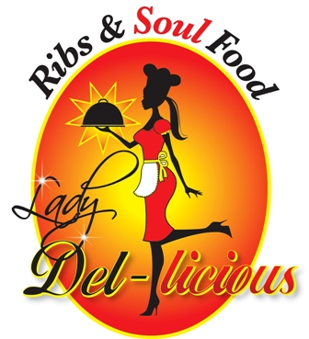
Specializing in Ribs and Soul Food

Where we serve you from soul to soul

Most Deliveries are Available
Phone (630) 613.9840
http://www.ladydel-licious.com
Or email me at Della@ladydel-licious.com

Ladydel-licious

Menu

Appetizers
Items are subject to change for catering parties
Della’s Fried Pickles and sauce  Sauce-dill, bbq, honey mustard | $8.75
Catfish Nuggets | $8.00
Traditional Holiday Dinners
Only for catering at this time. Prices are based upon headcount.

Succulent Turkey

“Ooo-We” Pot Roast with vegatables
Cornbread Dressing

“Pinch yo fingers eating”
Greens
(Cooked in smoked turkey tails or pork ham hocks)

“What U say”

Macoroni & cheese

“Can’t stop eating”

Potato Salad

“Yum Yum” Green Beans and potatoes with smoke meat

BAR – B – QUE
Only for catering at this time. Prices are based upon headcount

Spare Ribs

Rib Tips

Lamb Ribs

Beef Ribs

Chicken thighs and legs

Chicken wings

Mild or Hot Links
Breads
Homemade yeast rolls(15 rolls)  (Require a two week notice before event) | $20.00
Cornbread (serving for 10) | $8.00

Side Items
Only for catering at this time. Proces are based upon headcount.
Cranberry Sauce Tray(in orders for 10)
Garden Salad
Pasta Salad
Spaghetti w meat
Red Beans and Rice
Cole Slaw
Plantain
Fries

Desserts
Pound Cake | $25.00
Peach Cobbler | $22.50
Carmel Cake | $30.00
Banana Pudding | $20.00

